API Client

🌐 What is an API Client
# Source: AI Source: Provided by: [Data Path: Persons Table -> ID Column: 1, Name_En Column: Motasem Essam] -> From: [ChatGPT] on [1/19/2026]
An API Client is any software, application, or service that sends requests to an API and consumes its responses.
👉 Think of the API Client as the consumer of the API — it talks to the API through endpoints and processes the returned data.

🔑 Key Points About API Clients
# Source: AI Source: Provided by: [Data Path: Persons Table -> ID Column: 1, Name_En Column: Motasem Essam] -> From: [ChatGPT] on [1/19/2026]
- Sends Requests
  - Makes HTTP requests (GET, POST, PUT, DELETE) to API endpoints
- Receives Responses
  - Gets structured data (JSON, XML, etc.) from the API
- Can Be Any Application
  - Web applications (React, Angular)
  - Mobile apps (iOS, Android)
  - Server-side scripts or microservices
  - Tools like Postman or cURL
- Handles API Logic
  - Processes returned data
  - Displays it to users (UI)
  - Or passes it to other systems/services

🧱 Example: Web App as an API Client
# Source: AI Source: Provided by: [Data Path: Persons Table -> ID Column: 1, Name_En Column: Motasem Essam] -> From: [ChatGPT] on [1/19/2026]
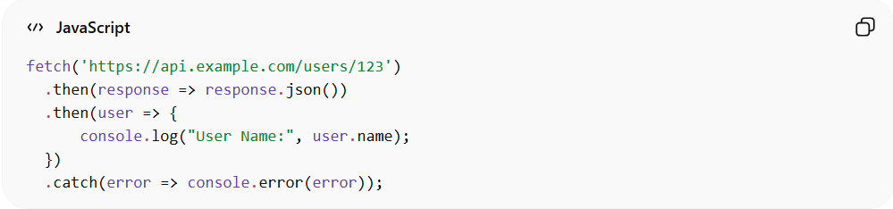
fetch('https://api.example.com/users/123')
.then(response => response.json())
.then(user => {
console.log("User Name:", user.name);
})
.catch(error => console.error(error));
Here:
- fetch → sends request to API endpoint
- API → returns the resource representation (user JSON)
- Client → processes and displays it

✅ Examples of API Clients
# Source: AI Source: Provided by: [Data Path: Persons Table -> ID Column: 1, Name_En Column: Motasem Essam] -> From: [ChatGPT] on [1/19/2026]
- Web frontend → React, Angular, Vue
- Mobile app → iOS, Android
- Server-side script → Node.js, Python, Java
- Testing tools → Postman, Insomnia
- Third-party service → integrates with your API

❌ Common Mistakes
# Source: AI Source: Provided by: [Data Path: Persons Table -> ID Column: 1, Name_En Column: Motasem Essam] -> From: [ChatGPT] on [1/19/2026]
- Treating API client as part of the API logic ❌
- Hardcoding API responses in client instead of requesting data ❌
- Tight coupling: client cannot easily switch APIs ❌

💡 Summary
# Source: AI Source: Provided by: [Data Path: Persons Table -> ID Column: 1, Name_En Column: Motasem Essam] -> From: [ChatGPT] on [1/19/2026]
An API Client is the consumer of an API, sending requests to endpoints, and processing the returned resources.

